Question 1:
#include <stdio.h>
int main(){
int arr[5],i=0;
printf("enter elements");
for (i=0;i<5;i++){
scanf("%d",&arr[i]);
}for(i=0;i<5;i++){
printf("\n %d element is position %d",arr[i],i);
}return 0;
}
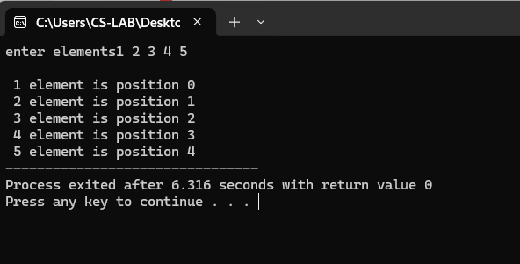
Question 2:
#include <stdio.h>
int main() {
int n, i, sum = 0;
printf("Enter the number of elements in the array: ");
scanf("%d", &n);
int arr[n];
for (i = 0; i < n; i++) {
printf("Enter element %d: ", i + 1);
scanf("%d", &arr[i]);
}
for (i = 0; i < n; i++) {
sum += arr[i];
}
printf("The sum of the elements in the array is: %d\n", sum);
return 0;
}
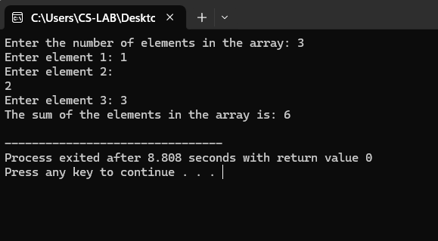

Question 3:
#include<stdio.h>
int main(){
int found=0,search,n,i=0;
printf("enter number of elements:");
scanf("%d",&n);
int a[n];
printf("\n enter elements of the array:");
for(i=0;i<n;i++){
scanf("%d",&a[i]);
}printf("\n enter element to be searched:");
scanf("%d",&search);
for(i=0;i<n;i++){
if (a[i]==search){
printf("element found at position %d",i);
found=1;
}if (!found){
printf("element not found!");
}
}return 0;
}

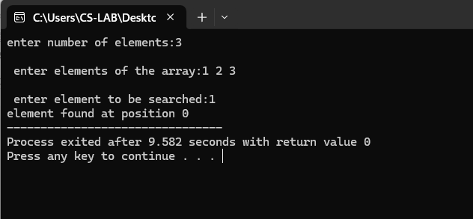
Question 4:
#include<stdio.h>
int main(){
int a[5],smallest,largest,i;
for(int i=0;i<5;i++){
printf("enter element:");
scanf("%d",&a[i]);
}largest=a[0];
smallest=a[0];
for(int i=0;i<5;i++){
if(a[i]>largest){
largest=a[i];
}if(a[i]<smallest){
smallest=a[i];
}}printf("\n largest= %d",largest);
printf("\n smallest= %d",smallest);\
return 0;
}
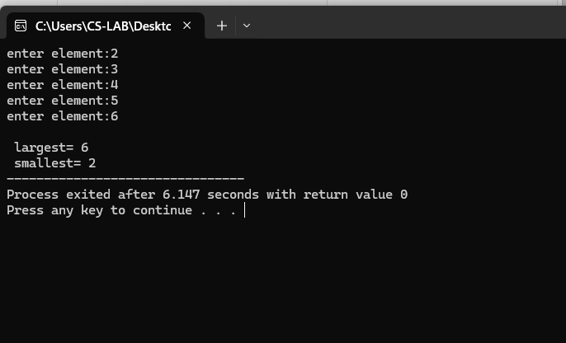
Question 5:
#include <stdio.h>
int main() {
int num[20];
int i, j, a, n;
printf("Enter number of elements in an array: ");
scanf("%d", &n);
printf("Enter the elements:\n");
for (i = 0; i < n; ++i) {
scanf("%d", &num[i]);
}
for (i = 0; i < n; ++i) {
for (j = i + 1; j < n; ++j) {
if (num[i] > num[j]) {
a = num[i];
num[i] = num[j];
num[j] = a;
}
}
}
printf("The numbers in ascending order are: ");
for (i = 0; i < n; ++i) {
printf("%d ", num[i]);
}
printf("\n");
return 0;
}
